Date: 25.06.2021
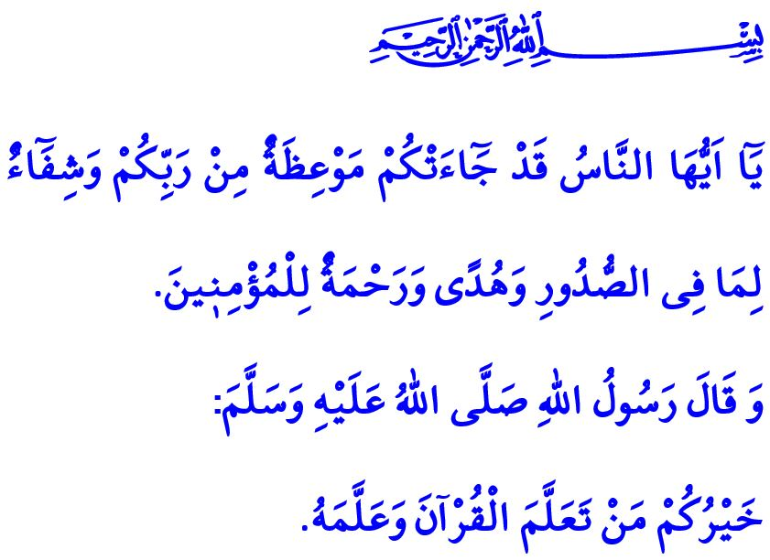
SPIRITUAL CLIMATE OF THE HOLY QUR’AN
Honorable Muslims!
It was one of those days in Madinah, full of peace. The Prophet Muhammad (saw) summoned Abdullah ibn Masud and said to him, “O Abdullah! Recite (of the Qur’an) for me.” Abdullah was surprised for a moment and replied, “Shall I recite it to you although it had been revealed to you?” The Messenger of Allah (saw) said, “I like to hear (the Qur’an) from others.” Thereupon, Abdullah ibn Masud started to recite from the Surah al-Nisa. Eventually,
when he came to recite the verse, “So how [will it be] when We bring from every nation a witness and We bring you, [O Muhammad], against these [people] as a witness?”, tears started to roll down from the eyes of the Messenger of Mercy (saw) and he said, “Stop, enough.”
Dear Believers!
The Qur’an is the book of Allah (swt) and the most beautiful and correct of all words. It is our source of healing, guide to salvation, and means of the mercy of Allah (swt) for us that leads us to the right path. In this regard, it is stated in one verse as follows, “O mankind! There has come to you instruction from your Lord and healing for what is in the breasts and guidance and mercy for the believers.”
Right! The Holy Qur’an is a unique address by the Almighty Allah (swt) to bring people out of the darkness of unbelief and into the light of guidance. It is a voice and sigh of relief from al-Rahman that provides ease for our overwhelmed hearts. It is the most valuable entrustment the Prophet Muhammad (saw) left for his ummah.
Dear Muslims!
Reciting, correctly understanding, and duly living up to the Holy Qur’an should be the primary purpose of our life. Enabling our children, who are the light of our eyes, to meet with the spiritual climate of the Qur’an and teaching our children its messages as well as what it regards halal and haram should be our greatest ideal. Let us not forget that our children each are entrustment to us from the Almighty Allah (swt). We can look out for this rare entrustment in the best way only through raising them in the guidance of the Qur’an and the Sunnah. It is our most important duty to raise our children as generations with the consciousness of being a servant of Allah (swt) and ummah of the Messenger of Allah (saw), with good morals, and as beneficial people for their homeland, nation, and humanity. As in the words of the Prophet Muhammad (saw), “There is no gift that a father gives his child more virtuous than good manners.”
Dear Believers!
A season of nice opportunity is around the corner for our children to meet with and get introduced to the Holy Qur’an, worships, and the exemplary life of the Prophet Muhammad with the summer Qur’an courses.
Let us enable our children, who are our tomorrows and the light of our eyes, to have the blessing of the Qur’an, which is the divine dinner table of the Almighty Allah (swt) on the face of earth. Let us lead the way to ensure that the hearts and minds are illuminated by the light of the Qur’an. Let us be the means to ensure that the love for Allah and His Messenger, and Islam and the Qur’an are ingrained in innocent hearts.
I would like to conclude this Friday’s khutbah with the following hadith of the Prophet Muhammad (saw), “The best among you is the one who learns the Qur’an and teaches it.”

Nisa, 4/41.
Bukhari, Fadhail al-Qur’an, 33.
Yunus,10/57.
Tirmidhi, Birr, 33.
Tirmidhi, Fadhail al-Qur’an, 15. General Directorate of Religious Services

